Name: AbdullahTahir

**Part 1**

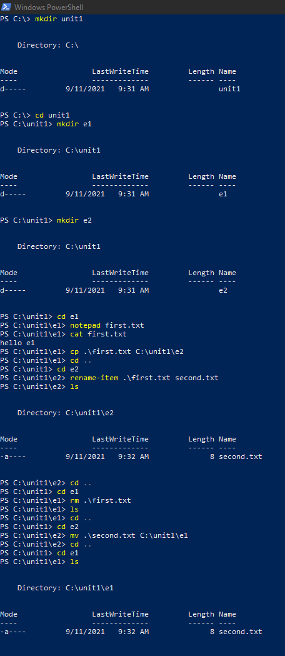

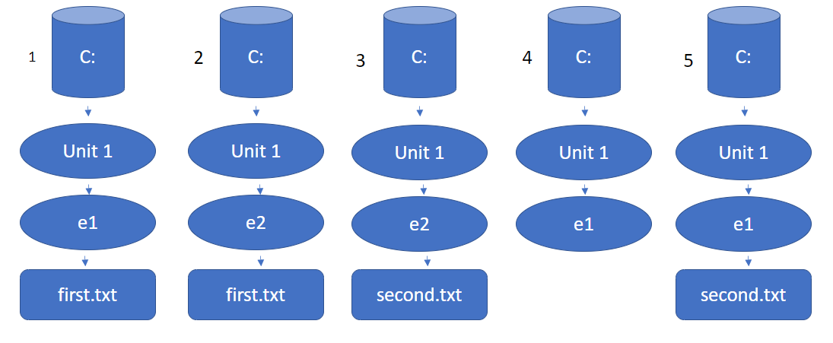

11) From C:\unit1\e2\ the relative path is: .. \e3

12) C:\unit1\e1\

13) Ls *.txt

14) Ls *e*

**Part 2**

